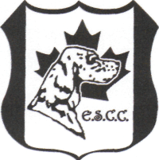
THE ENGLISH SETTER CLUB OF CANADA

APPLICATION FOR ANNUAL AWARDS

Award Year: 2016

CKC Dog Registration Number:______________________________________________

Name of Applicant: _______________________________________________

Address: _______________________________________________

City: ______________ Province/State: ______________ Postal/Zip Code:__________

Phone: _________________________ Email:___________________________________

REGISTERED NAME OF DOG:______________________________________________
(Please print carefully. This information will be engraved on the award)

REGISTERED OWNER(S): ______________________________________________
(As appears on CKC registration form)

AWARDS APPLIED FOR: ______________________________________________

______________________________________________

_______________________________________________

If applying for an award for more than one dog, please use a separate form for each dog. Please copy this form.

Make sure all information required for the award applied for is listed on a separate sheet (show, date, wins, points, etc.) Attach this application form to your show information sheet.

I have met all the rules of eligibility as outlined by the E.S.C.C.

Date of Application:_____________, 2017 Signature of Applicant:______________________

Send to: Kathy Hawker, 120 Windermere Crescent, Edmonton, Alberta T6W 0S3
or Maldawn@aol.com or Fax to: 780-433-1184

DEADLINE: Please ensure your application reaches the Tabulator by June 20, 2017

